Operating System Lab Assignment: II

[4ITRC2]

Manshaa Kakani | BE: II Year | Information Technology (IT): A

Table of Contents

▪ Aim: 2

▪ To perform: 2

▪ To Submit: 2

▪ How to Submit: 2

▪ C Codes and outputs 2

# Aim:

To create C programs for the different scheduling algorithms.

# To perform:

Create and execute C programs for following CPU Scheduling Algorithms:

1. First Come First Serve (FCFS)

2. Shortest Job First (SJF)

3. Round Robin Scheduling

# To Submit:

C Codes for the above scheduling algorithms with their outputs.

# How to Submit:

Prepare your content in word/notepad, with every page watermarked with your name and roll number. Upload on Github and submit the link in the google form attached.

# C Codes and outputs

1. First Come First Serve [FCFS]

#include <stdio.h>

struct Process {

int id;

int arrival_time;

int burst_time;

int completion_time;

int turnaround_time;

int waiting_time;

};

int main() {

int n, i;

printf("Enter number of processes: ");

scanf("%d", &n);

struct Process processes[n];

printf("Enter Arrival and Burst time for each process:\n");

for (i = 0; i < n; i++) {

processes[i].id = i + 1;

printf("Process %d (Arrival Burst): ", processes[i].id);

scanf("%d %d", &processes[i].arrival_time, &processes[i].burst_time);

}

int current_time = 0;

for (i = 0; i < n; i++) {

if (current_time < processes[i].arrival_time) {

current_time = processes[i].arrival_time;

}

processes[i].completion_time = current_time + processes[i].burst_time;

processes[i].turnaround_time = processes[i].completion_time - processes[i].arrival_time;

processes[i].waiting_time = processes[i].turnaround_time - processes[i].burst_time;

current_time = processes[i].completion_time;

}

float total_tat = 0, total_wt = 0;

printf("\nFCFS Results:\n");

printf("Process\tArrival\tBurst\tComplete\tTurnaround\tWaiting\n");

for (i = 0; i < n; i++) {

printf("P%d\t%d\t%d\t%d\t\t%d\t\t%d\n",

processes[i].id, processes[i].arrival_time, processes[i].burst_time,

processes[i].completion_time, processes[i].turnaround_time, processes[i].waiting_time);

total_tat += processes[i].turnaround_time;

total_wt += processes[i].waiting_time;

}

printf("Average Turnaround Time: %.2f\n", total_tat / n);

printf("Average Waiting Time: %.2f\n", total_wt / n);

return 0;

}

Sample Input:

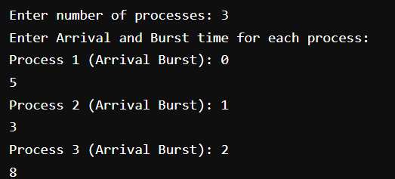

Output:

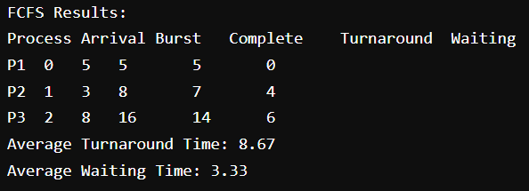

1. Shortest Job First [SJF]

#include <stdio.h>

#include <stdlib.h> // For qsort

struct Process {

int id;

int arrival_time;

int burst_time;

int completion_time;

int turnaround_time;

int waiting_time;

};

int compareArrivalTime(const void *a, const void *b) {

return ((struct Process *)a)->arrival_time - ((struct Process *)b)->arrival_time;

}

int main() {

int n, i, current_time = 0;

printf("Enter number of processes: ");

scanf("%d", &n);

struct Process processes[n];

printf("Enter Arrival and Burst time for each process:\n");

for (i = 0; i < n; i++) {

processes[i].id = i + 1;

printf("Process %d (Arrival Burst): ", processes[i].id);

scanf("%d %d", &processes[i].arrival_time, &processes[i].burst_time);

}

qsort(processes, n, sizeof(struct Process), compareArrivalTime);

int completed = 0;

int current_process_index;

struct Process executed_order[n];

int executed_count = 0;

while (completed < n) {

current_process_index = -1;

int shortest_burst = 9999;

for (i = 0; i < n; i++) {

int is_completed = 0;

for (int j = 0; j < executed_count; j++) {

if (processes[i].id == executed_order[j].id) {

is_completed = 1;

break;

}

}

if (processes[i].arrival_time <= current_time && !is_completed) {

if (processes[i].burst_time < shortest_burst) {

shortest_burst = processes[i].burst_time;

current_process_index = i;

}

}

}

if (current_process_index == -1) {

current_time++;

} else {

processes[current_process_index].completion_time = current_time + processes[current_process_index].burst_time;

processes[current_process_index].turnaround_time = processes[current_process_index].completion_time - processes[current_process_index].arrival_time;

processes[current_process_index].waiting_time = processes[current_process_index].turnaround_time - processes[current_process_index].burst_time;

current_time = processes[current_process_index].completion_time;

executed_order[executed_count++] = processes[current_process_index];

completed++;

}

}

float total_tat = 0, total_wt = 0;

printf("\nSJF Results:\n");

printf("Process\tArrival\tBurst\tComplete\tTurnaround\tWaiting\n");

for (i = 0; i < n; i++) {

printf("P%d\t%d\t%d\t%d\t\t%d\t\t%d\n",

processes[i].id, processes[i].arrival_time, processes[i].burst_time,

processes[i].completion_time, processes[i].turnaround_time, processes[i].waiting_time);

total_tat += processes[i].turnaround_time;

total_wt += processes[i].waiting_time;

}

printf("Average Turnaround Time: %.2f\n", total_tat / n);

printf("Average Waiting Time: %.2f\n", total_wt / n);

return 0;

}

Sample Input:

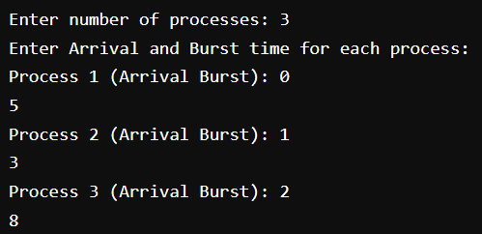

Output

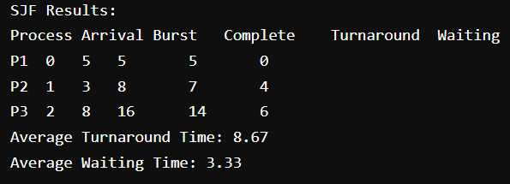

1. Round Robin Scheduling

#include <stdio.h>

#include <stdlib.h>

#include <stdbool.h>

struct Process {

int id;

int arrival_time;

int burst_time;

int remaining_time;

int completion_time;

int turnaround_time;

int waiting_time;

bool in_queue;

};

int main() {

int n, i, time_quantum;

int current_time = 0, completed = 0;

printf("Enter number of processes: ");

scanf("%d", &n);

struct Process processes[n];

printf("Enter Arrival Time and Burst Time for each process:\n");

for (i = 0; i < n; i++) {

processes[i].id = i + 1;

printf("Process %d (Arrival Burst): ", processes[i].id);

scanf("%d %d", &processes[i].arrival_time, &processes[i].burst_time);

processes[i].remaining_time = processes[i].burst_time;

processes[i].completion_time = 0;

processes[i].in_queue = false;

}

printf("Enter Time Quantum: ");

scanf("%d", &time_quantum);

int queue[100];

int front = 0, rear = 0;

queue[rear++] = 0; // Enqueue first process

processes[0].in_queue = true;

while (completed < n) {

int index = queue[front++];

if (processes[index].remaining_time <= time_quantum) {

current_time = (current_time < processes[index].arrival_time) ? processes[index].arrival_time : current_time;

current_time += processes[index].remaining_time;

processes[index].remaining_time = 0;

processes[index].completion_time = current_time;

completed++;

} else {

current_time = (current_time < processes[index].arrival_time) ? processes[index].arrival_time : current_time;

processes[index].remaining_time -= time_quantum;

current_time += time_quantum;

}

// Add newly arrived processes to queue

for (i = 0; i < n; i++) {

if (processes[i].arrival_time <= current_time &&

processes[i].remaining_time > 0 &&

!processes[i].in_queue) {

queue[rear++] = i;

processes[i].in_queue = true;

}

}

// If current process is not finished, add it back to queue

if (processes[index].remaining_time > 0) {

queue[rear++] = index;

}

}

float total_tat = 0, total_wt = 0;

for (i = 0; i < n; i++) {

processes[i].turnaround_time = processes[i].completion_time - processes[i].arrival_time;

processes[i].waiting_time = processes[i].turnaround_time - processes[i].burst_time;

total_tat += processes[i].turnaround_time;

total_wt += processes[i].waiting_time;

}

printf("\nRound Robin Results (Time Quantum: %d):\n", time_quantum);

printf("Process\tArrival\tBurst\tComplete\tTurnaround\tWaiting\n");

for (i = 0; i < n; i++) {

printf("P%d\t%d\t%d\t%d\t\t%d\t\t%d\n",

processes[i].id, processes[i].arrival_time, processes[i].burst_time,

processes[i].completion_time, processes[i].turnaround_time, processes[i].waiting_time);

}

printf("\nAverage Turnaround Time: %.2f\n", total_tat / n);

printf("Average Waiting Time: %.2f\n", total_wt / n);

return 0;

}

Sample Input:

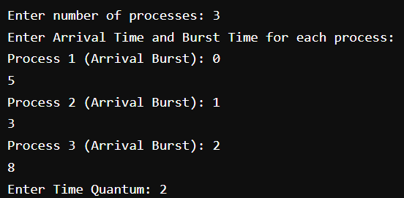

Output:

